**Acropolis Institute of Technology & Research (AITR), Indore**

**JAVA Programming (CS 406)**

1. Write a program in JAVA for printing all prime numbers up to 1000.
2. Write a program in JAVA for printing mark sheet of student for 5 subjects.
3. Write a program in JAVA for arithmetic operation and taking integer value in runtime from command prompt.
4. Write a program in JAVA for arithmetic operation and taking float value in runtime from command prompt.
5. Write a program in JAVA for checking, is given year Leap or Not.
6. Write a program in JAVA for conversion Fahrenheit to Celsius and vice-versa.
7. Write a program in JAVA for calculating simple interest using class and object.
8. Assign value to variable by object of class
9. Without using constructor
10. With using constructor
11. Write a program in JAVA for Arithmetic operation using class and object.
12. Assign value to variable by object of class
13. Without using constructor
14. With using constructor
15. Write a program in JAVA demonstrate Inheritance :-

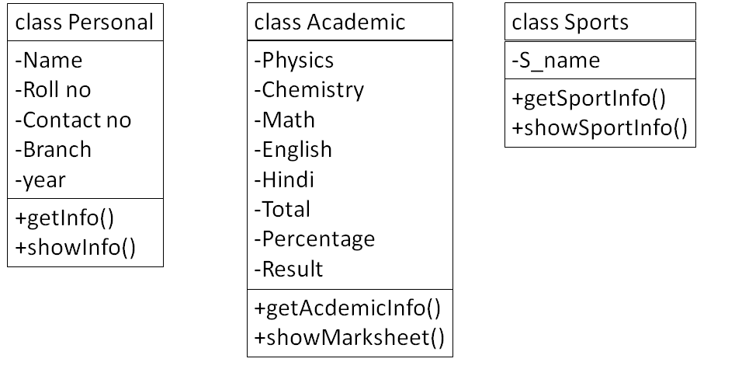

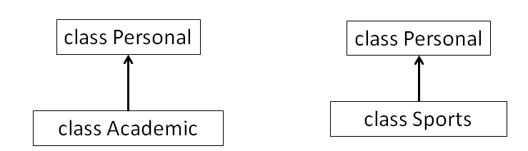

**Single Inheritance**

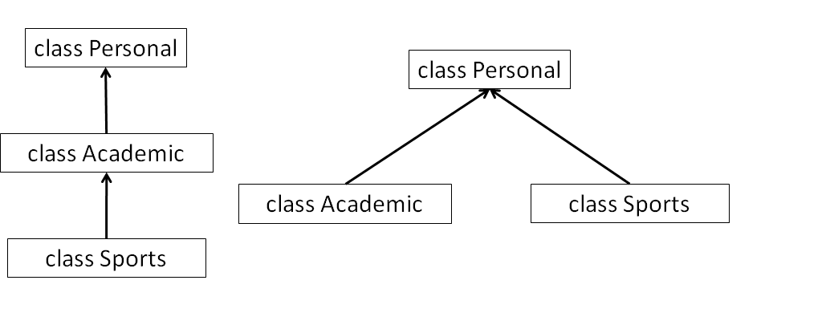

**Multilevel Inheritance Hierarchical Inheritance**

1. **Problem: Banking System**

* **Bank Account Class:** This serves as the base class for all types of bank accounts. It should have the following properties and methods:

**Properties:** account number, account holder name, and balance.

**Methods:** deposit, withdraw, and getBalance.

* **Savings Account Class:** This is a subclass of Bank Account. It should include the following additional properties and methods:

**Properties:** interest rate.

**Methods:** addInterest, which calculates and adds interest to the account balance.

* **Checking Account Class:** Another subclass of Bank Account. It should include the following additional properties and methods:

**Properties:** transaction fee.

**Methods:** withdraw (overrides the parent class method to include transaction fee deduction).

**Your program should allow the user to perform the following actions:**

Create different types of bank accounts (savings or checking).

Deposit money into an account.

Withdraw money from an account (considering overdraft for checking accounts).

Display the current balance of an account.

For savings accounts, the system should calculate and add interest periodically.

Properly handle and display errors (e.g., insufficient funds).

1. Write a program in JAVA demonstrate overloading and overriding concept (Perform arithmetic operation)
2. Write a program in JAVA demonstrate final, super and this keyword in inheritance and polymorphism concept.
3. Write a program in JAVA demonstrate user define packages and importing that package.
4. Write a program in JAVA demonstrate thread concept.
5. Write a program in JAVA demonstrate string operations.